**AFRL Research Collaboration Program**

**Contract FA8650-13-C-5800**

**Effect of Constituents and Microstructure on Energy Dissipation Mechanisms During Damage Growth**

**University: Texas A&M University**

**REPORT COVERS PERIOD: 7-1-17 THRU 9-30-17**

1. **PROJECT TEAM MEMBERS**
2. **LEAD UNIVERSITY POC:** John Whitcomb, 979-845-4006, jdw@tamu.edu
3. **PROJECT TEAM MEMBERS:** John Whitcomb, Collin Blake
4. **AFRL TECHNICAL POC:** Craig Przybyla
5. **TECHNICAL DISCUSSION**
6. **CURRENT WORK**Development of the infrastructure to perform mesoscale analysis of 3D textile composites.

**Background**

In the past couple of years, another graduate student, Scott McQuien, explored the accuracy of the VTMS suite of tools in predicting stresses in plain weave composites. Although Scott discovered a number of issues with the software, the geometry modeling capabilities were quite promising. Early in the last quarter, Keith Ballard, developed techniques to use the geometry calculated using VTMS and other modeling tools to develop a standard finite element model for a 3D textile composite. Based on Scott’s and Keith’s experience, we decided there was excellent potential for developing finite element models using the geometry engine. However, difficulties that Scott and Keith experienced convinced us that we needed to take a fresh look at the geometry creation component of VTMS and the subsequent finite element mesh generation. This summer Collin began working on resolving penetrating regions between geometric models in VTMS. These regions pose a significant and complex problem that, when solved, will significantly improve VTMS and the resulting models. The following describes Collin’s activities during the quarter. I should point out that Keith Ballard is not supported by this contract, but does provide mentoring for Keith. Scott McQuien was supported last summer as an intern at AFRL, during which time he helped identify some errors in the VTMS coding.

**Approach**

VTMS conducts a four-step process to generate geometric textile models. The results of this process are shown in Figure 1.

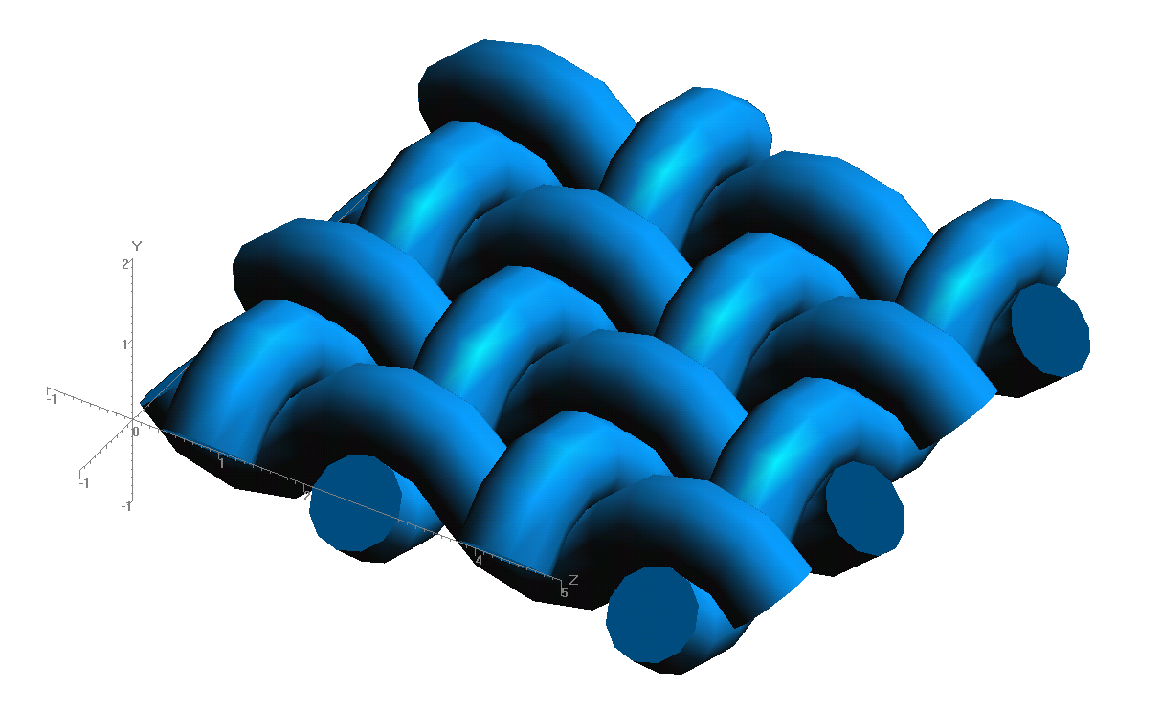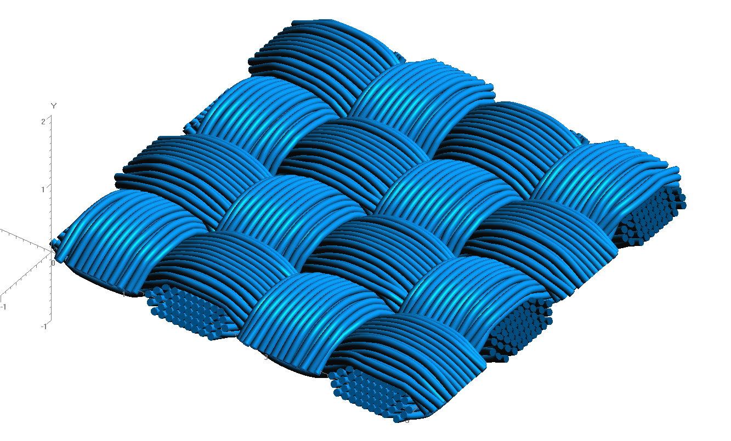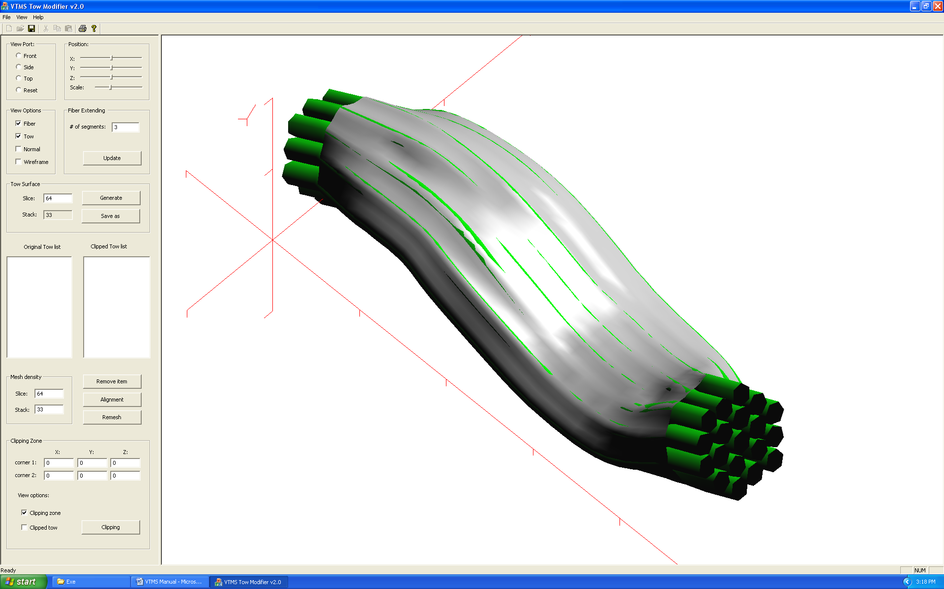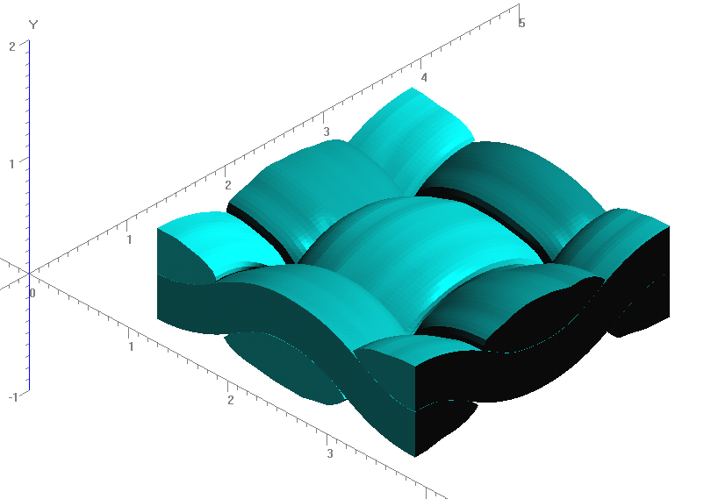

**Figure 1: Evolution of Weave Tow Geometry**

Once the relatively discrete model of the geometry has been relaxed into a realistic woven shape, the discrete filaments (top right of Figure 1) are represented in a surface fit of the general shape (bottom left of Figure 1). The surface fits result in regions of overlapping surfaces, which causes significant issues in meshing these models. These surfaces are defined by nodes that are connected in a fashion similar to a mesh. These surface nodes can be determined as penetrating another surface geometry by a method inside of VTMS. The focus of the last quarter has been to resolve penetrations between surface definitions of the textile geometry.

**Figure 2: Rough Sketch of Penetration Phenomena**

Figure 2 shows a representation of a series of penetrations between two geometries, one running in the plane of the page, the other running out of the page. Illustrated are multiple regions that need to be resolved.

The first attempt at a solution was to define a plane that represents a contact surface between the geometries. This surface could then be used as a domain to resolve a penetrated region. This plane could also be used to define a compatible mesh between the two geometries for an analysis. Unfortunately, this method could not be adapted for multiple regions of penetrations, as illustrated in Figure 2 above. This is due to the relatively large curvature of certain geometries along with the three-dimensional nature of the models.

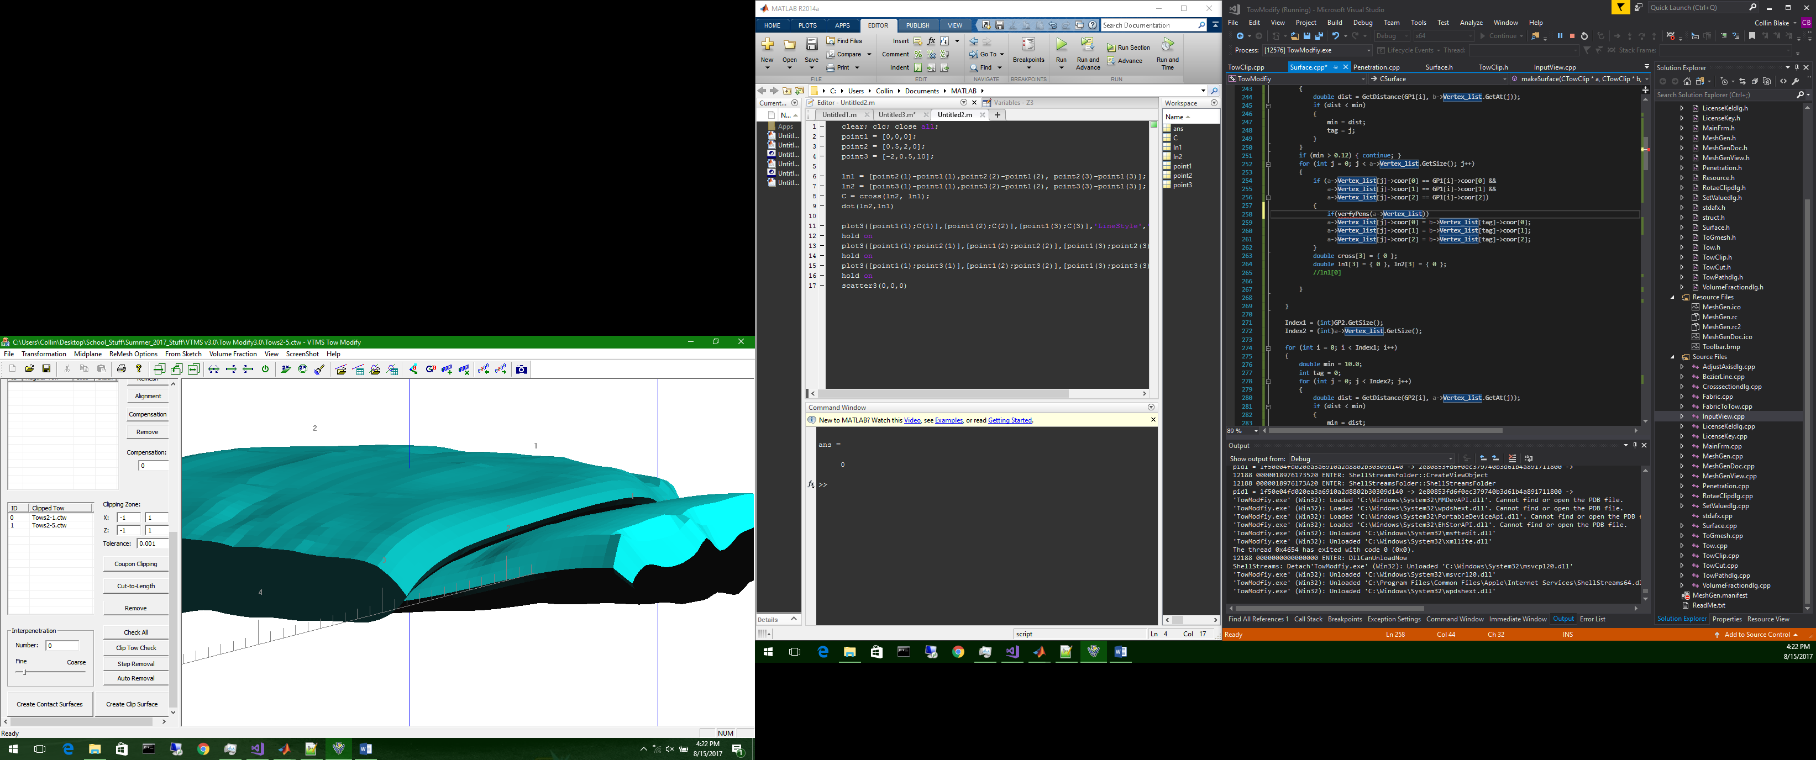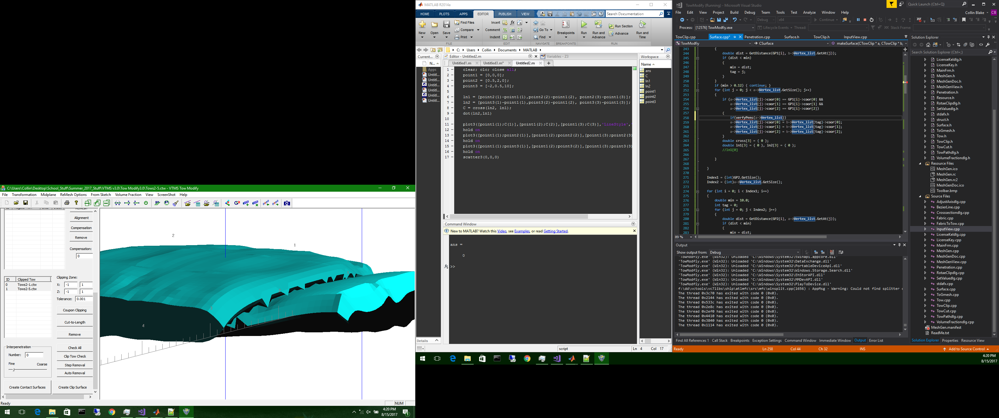The second method developed was a routine that paired penetrating nodes between the two surfaces by determining which nodes were in closest proximity. The routine then assigned both nodes to the halfway point between their original locations. This routine easily solved compatibility and solve the penetration regions. However, this solution was not robust for the case of single node penetration regions and resulted in some models having a significant change in surface geometry, as seen in Figure 3.

**Figure 3: Two Surfaces with Significant Boundary Changes Before (Left) and After (Right) Routine**

After further investigation, it became apparent that the penetration detection routine in VTMS was not entirely accurate for certain geometries. This discovery lead into a need for a method that could cover both aspects of the problem.

Our current efforts are now focused on the implementation and use of a Non-Uniform Rational B-Spline (NURBS) surface algorithm written by the Geometry Group at SINTEF ICT, Department of Applied Mathematics. A NURBS surface is an analytical representation of a surface that can be evaluated at any point on the surface. The representation can be fitted to existing data points in three dimensions. It will allow us to determine an intersection curve that accurately describes the region of penetrations. NURBS also detects single node penetrations which can be difficult to find and resolve. Currently, we are able to fit a surface for a geometry (Figure 4) and detect full regions of penetrations (Figure 5).

**Figure 4: VTMS Surface (Left) and a NURBS Representation (Left) of the Same Surfaces**

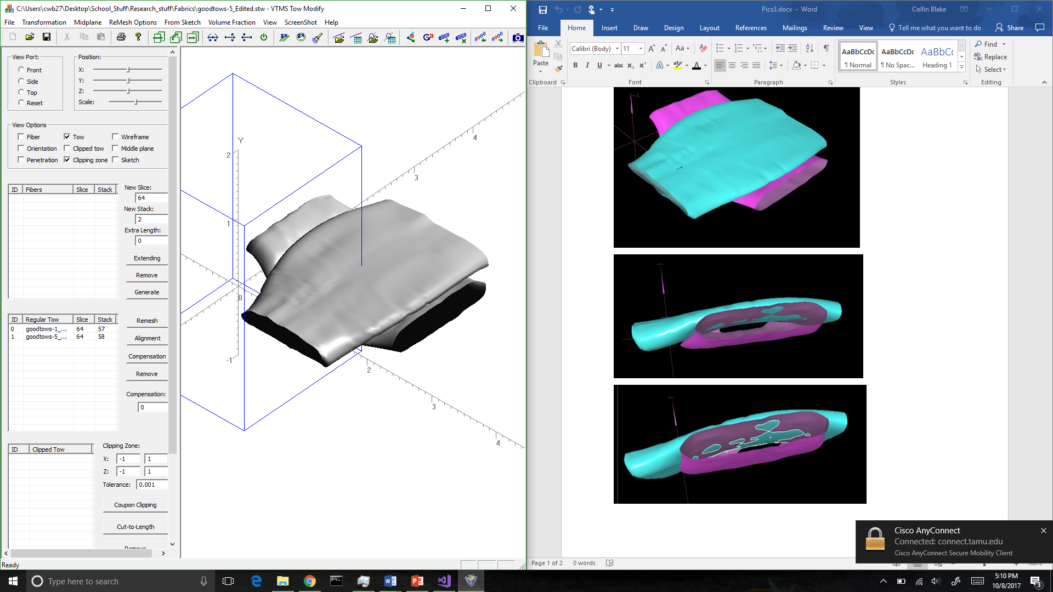

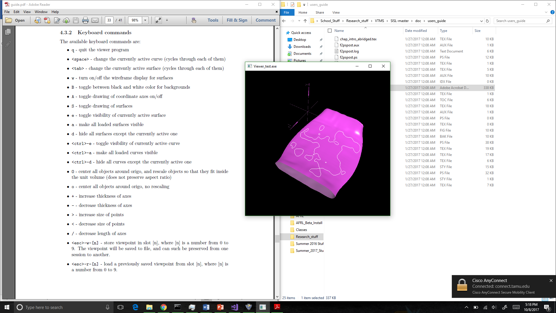This method shows promise allowing a more robust method for detecting and resolving penetrations in these models.

**Figure 5:Surface with Penetrating Regions Outlined in White**

1. **CONCLUSIONS/ANALYSIS TO DATE**

Resolving penetrations in surface representations of textile geometries will significantly improve these models and reduce the amount of pre-processing required to run an analysis. After unsuccessful attempts with various routines, we are currently pursuing the use of NURBS surfaces. To date, they are proving more robust for detecting penetrations and are being evaluated for their contribution to resolving them.

1. **WORK FORECAST AND PLANS**The next step is to utilize the boundary curves of the detected penetration regions to resolve the penetrations. We will determine the best method of resolution beginning with simple volume subtraction of one volume from the other. A study will be conducted to measure the reduction in volume to verify how much the method effects the geometries. We will then begin implementation into VTMS.